**Ata dos Redes sociais dos membros do DADEE gestão 2020.1**

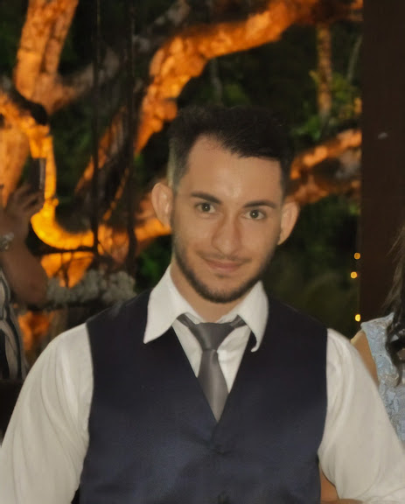

André Luiz

facebook: [www.facebook.com/AndreLuiz042](http://www.facebook.com/AndreLuiz042)

Instagram: <https://www.instagram.com/andreluiz042/?hl=en>

Linkedin: <https://www.linkedin.com/in/andr%C3%A9-luiz-a5a3126a/>

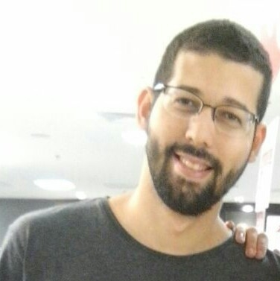

Valdemar Cavalcante

Linkedin: [www.linkedin.com/in/valdemar-cavalcante-276993122/](https://www.linkedin.com/in/valdemar-cavalcante-276993122/)

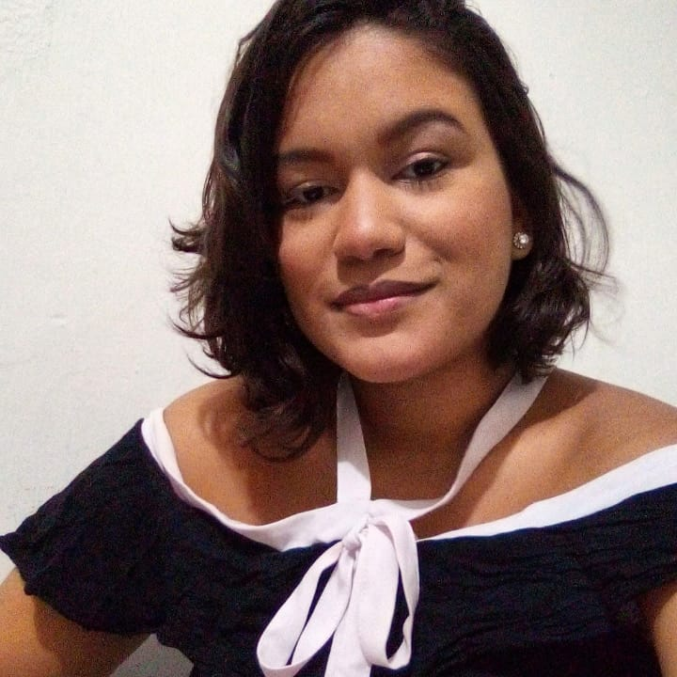 Évelin Félix ([www.linkedin.com/in/evelinfelix](http://www.linkedin.com/in/evelinfelix))

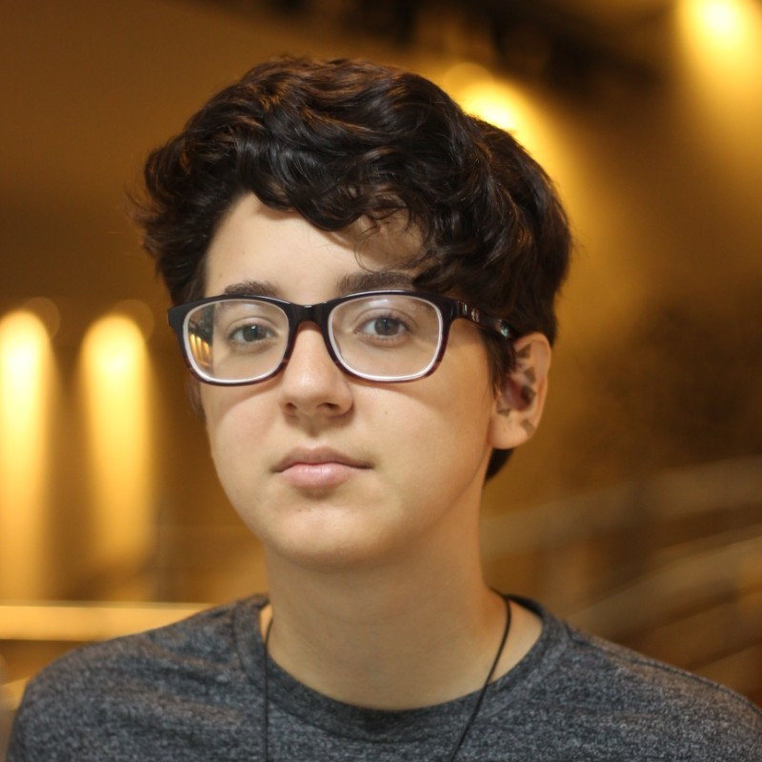 Maria Helena Alencar ([www.linkedin.com/in/maria-helena-alencar-25b8711a0](http://www.linkedin.com/in/maria-helena-alencar-25b8711a0))

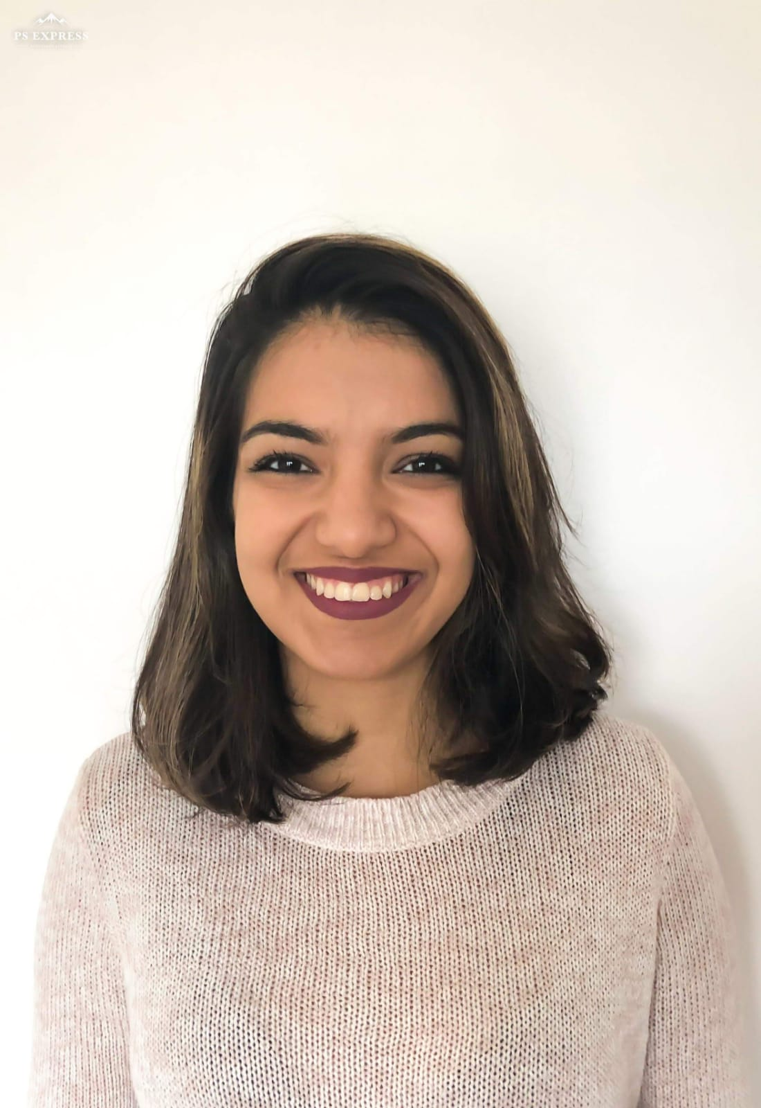 Ana Beatriz Melo ou Bia Melo (<https://www.linkedin.com/in/anabeatrizsmelo/>)

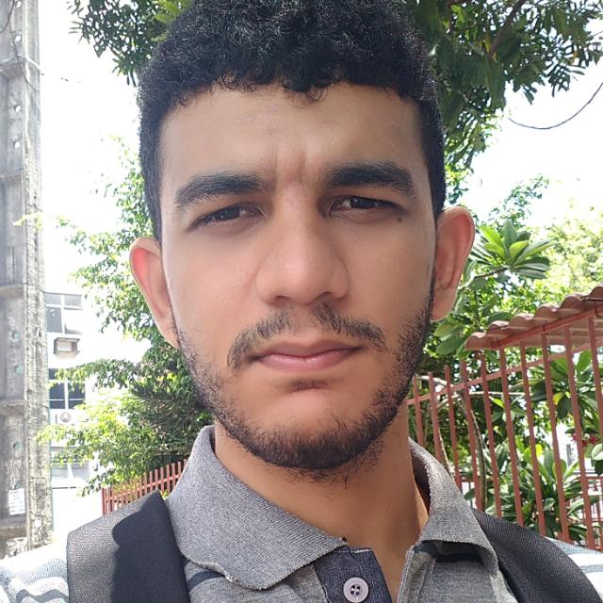 Pedro Paulo (<https://www.linkedin.com/in/pedro-paulo-silva-neto-94131a150/>)

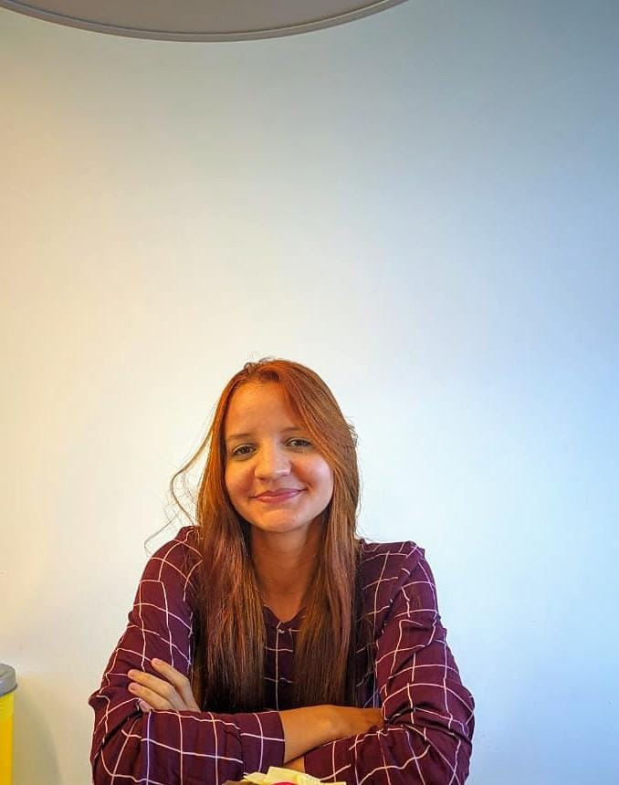 Ana Paula Araújo ([https://www.linkedin.com/in/ana-paula-araújo-91587798](https://www.linkedin.com/in/ana-paula-ara%C3%BAjo-91587798))